

Online Quiz

**1Mohammed Ashfaque, 2Kabir Selot, 3Mariyum Siddique,4Mahira Fakih,5Humza Khhan,**

1Assistant Professor

2-5Students, 1-5Department of Computer Engineering,

1Rizvi College of Engineering Mumbai, India.

***Abstract:*** Online examination system is a web-based examination system where examinations are given online. Either through the internet or internet using computer system. The main goal of this online examination system is to effectively evaluate the student thoroughly through a totally automated system that not only reduce the required time but also obtain fast and accurate results. The main objective of our software is to efficiently evaluate the candidate thoroughly through a fully automated system there is no need of paper and pen. The user can write exam without going to the exam centre. Also the website will provide a good.The very first step of any research process is to choose a topic. With a literature review, the parameters will be set by a central research question. Always keep in mind the purpose of a literature review is to represent previously conducted research and its developments related to a specific research question. Online Quiz System Project is really an interesting platform for testing your knowledge. It will provide users an online interface where they solve different quizzes online. The other interface will be controlled by the operator who will responsible to create, design and update the quizzes. The users or students will enter their particular ta login and solve a quiz of their choice. may contain mcqs or other Format as designed by the admin or teacher.

**Key Words: Online Quiz , literature review .**

1. **INTRODUCTION**

Online Quiz System is a web-based system, named for assessing students. Students can appear in a quiz from anywhere of the world wherever there's no interaction between pencil and paper rather interaction between computer and human being. The questions vary student to student for the same quiz while they are sitting in the quiz at the same time. Lecturers can use the Online Quiz System for evaluating their students effectively, efficiently and perfectly. Any university, college, school or educational institute should use this system for their organization to take quizzes.

Nowadays it's the most efficient and effective method of assessing distant students . One of the main benefits of our system is automated marking, that is, teachers do not need to check the answer script as they are doing in manual quizzes. The other advantage is saving valuable time for a teacher. On the other hand, students can score according to their merit level and it will give feedback about a student on which side he or she is weak. In recent years, the utilization of online quiz systems has become quite popular due to pressure of increasing class sizes and the need for more efficient and effective ways of assessing distant students. This is due to the popularity of distance education. Online Quiz System is a web based quiz system, a system that can be used by lecturers to evaluate students effectively, efficiently and perfectly

## RESEARCH METHODOLOGY

* 1. **Objective**

1. To develop a system that enables the student to answer the quiz online from any location. To analyze current problems in the existing system and make improvements through it. To design a system that can help the lecturer to create a quiz and schedule the quiz..

**Methodology Development Model**

The sequential phases in Waterfall model are − Requirement Gathering and analysis − All possible requirements of the system to be developed are captured in this phase and documented in a requirement specification document.

• **System Design** − The requirement specifications from first phase are studied in this phase and the system design is prepared. This system design helps in specifying hardware and system requirements and helps in defining the overall system architecture.

• **Implementation** − With inputs from the system design, the system is first developed in small programs called units, which are integrated in the next phase. Each unit is developed and tested for its functionality, which is referred to as Unit Testing.

• **Integration and Testing** − All the units developed in the implementation phase are integrated into a system after testing of each unit. Post integration the entire system is tested for any faults and failures.

• **Deployment of system** − Once the functional and non-functional testing is done; the product is deployed in the customer environment or released into the market.

• **Maintenance** − There are some issues which come up in the client environment. To fix those issues, patches are released. Also to enhance the product some better versions are released. Maintenance is done to deliver these changes in the customer environment.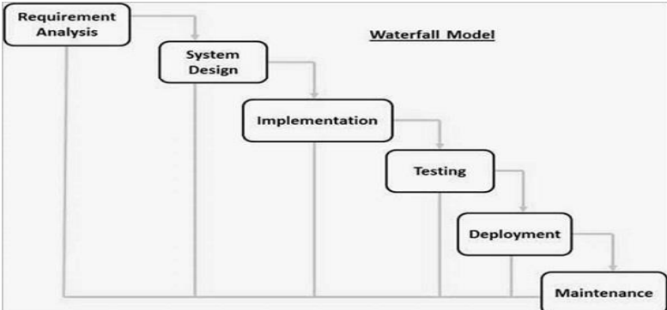

**Tools and Technique**

* Php
* Xampp
* Mysql yog
* HTML
* Bootstrap
* Sublime text
* Git hub
* Java Script
* Css

**Php**

**Hypertext Preprocessor** (or simply PHP) is a server-side scripting language designed for Web development, but also used as a general-purpose programming language. It was originally created by Rasmus Lerdorf in 1994,] the PHP reference implementation is now produced by The PHP Group. PHP originally stood for Personal Home Page, ] but it now stands for the recursive acronym PHP: Hypertext Preprocessor.

PHP code may be embedded into HTML code, or it can be used in combination with various web template systems, web content management systems, and web frameworks. PHP code is usually processed by a PHP interpreter implemented as a module in the web server or as a Common Gateway Interface (CGI) executable. The web server combines the results of the interpreted and executed PHP code, which may be any type of data, including images, with the generated web page. PHP code may also be executed with a command-line interface (CLI) and can be used to implement standalone graphical applications.

**Xampp**

XAMPP is a free and open source cross-platform web server solution stack package developed by Apache Friends, consisting mainly of the Apache HTTP Server, MariaDB database, and interpreters for scripts written in the PHP and Perl programming languages. XAMPP stands for Cross-Platform (X), Apache (A), MariaDB (M), PHP (P) and Perl (P). It is a simple, lightweight Apache distribution that makes it extremely easy for developers to create a local web server for testing and deployment purposes. Everything needed to set up a web server – server application (Apache), database (MariaDB), and scripting language (PHP) – is included in an extractable file. XAMPP is also cross-platform, which means it works equally well on 5 Linux, Mac and Windows. Since most actual web server deployments use the same components as XAMPP, it makes transitioning from a local test server to a live server extremely easy as well.

**Mysql** **yog**

MySQL Workbench is a unified visual tool for database architects, developers, and DBAs. MySQL Workbench provides data modeling, SQL development, and comprehensive administration tools for server configuration, user administration, backup, and much more. MySQL Workbench is available on Windows, Linux and Mac OS X.

**HTML**

Hypertext Markup Language (HTML) is the standard markup language for creating web pages and web applications. With Cascading Style Sheets (CSS) and JavaScript, it forms a triad of cornerstone technologies for the World Wide Web. [4]

Web browsers receive HTML documents from a web server or from local storage and render the documents into multimedia web pages. HTML describes the structure of a web page semantically and originally included cues for the appearance of the document.

HTML elements are the building blocks of HTML pages. With HTML constructs, images and other objects such as interactive forms may be embedded into the rendered page. HTML provides a means to create structured documents by denoting structural semantics for text such as headings, paragraphs, lists, links, quotes and other items.

**Bootstrap**

Bootstrap is a free and open-source front-end framework for designing websites and web applications. It contains HTML- and CSS-based design templates for typography, forms, buttons, navigation and other interface components, as well as optional JavaScript extensions. Unlike many web frameworks, it concerns itself with front-end development only.

**Java** **Script**

JavaScript often abbreviated as JS, is a high-level, interpreted programming language. It is a language which is also characterized as dynamic, weakly typed, prototype-based and multi-paradigm. Alongside HTML and CSS, JavaScript is one of the three core technologies of the World Wide Web. JavaScript enables interactive web pages and thus is an essential part of web applications. The vast majority of websites use it, and all major web browsers have a dedicated JavaScript engine to execute it.

**Sublime** **Text**

Sublime Text is a proprietary cross-platform source code editor with a Python application programming interface (API). It natively supports many programming languages and markup languages, and functions can be added by users with plugins, typically community-built and maintained under free-software licenses.

**Github**

GitHub is a web-based hosting service for version control using Git. It is mostly used for computer code. It offers all of the distributed version control and source code management (SCM) functionality of Git as well as adding its own features. It provides access control and several collaboration features such as bug tracking, feature requests, task management, and wikis for every project.

GitHub offers plans for both private repositories and free accountswhich are commonly used to host opensource software projects.

**Css**

Cascading Style Sheets (CSS) is a style sheet language used for describing the presentation of a document written in a markup language like HTML. CSS is a cornerstone technology of the World Wide Web, alongside HTML and JavaScript.

CSS is designed to enable the separation of presentation and content, including layout, colors, and fonts. This separation can improve content accessibility, provide more flexibility and control in the specification of presentation characteristics, enable multiple web pages to share formatting by specifying the relevant CSS in a separate css file, and reduce complexity and repetition in the structural content.

**Specification** **Requirement**

External Interfaces - This interface will be actual interface through which the user will communication with the application and perform the desired tasks.

Admin login

**I.D:**

**Role**: Admin wishes to login to the system

**Precondition**: Username and Password

**Success end Condition**: Main option of screen display

**Failed end Condition**: User has entered incorrect Username and 7 Password or both

Password or both

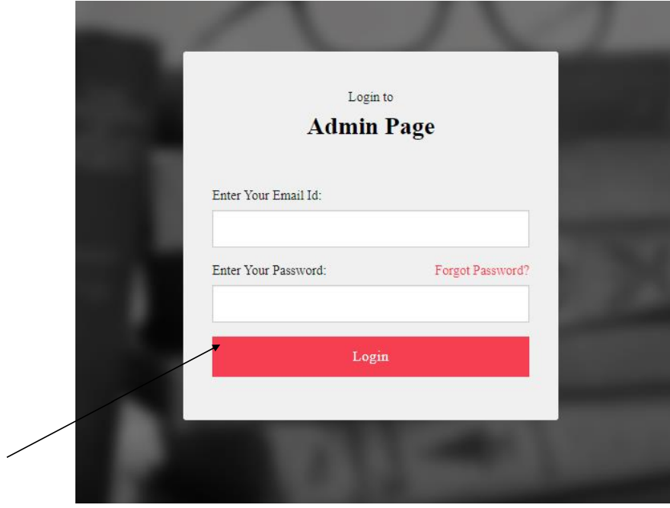

Delete

**ID**:

**Precondition**: Admin has successfully navigated to the Search result

**Success end Condition**: Admin has successfully made the Changes

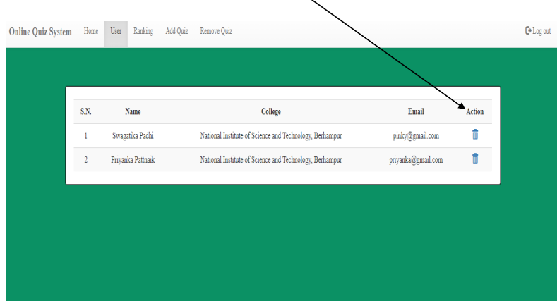

Hsu2222222eh

Advantage

• Engage audience in a unique and fun way and connect them to brand or learning material.

• Taking online quizzes makes it possible to have a large number of participants

• It is significant more easy to randomize your question with just one click than to do it all manually.

• Another plus of online quizzes is getting immediate results from your participants. Not only does the creator get the results, the participant itself is also possible to get his or her results.

• There are several ways to gain more brand awareness.

• It’s possible to show one question at the time with online quizzes. People are not able to skip a question, because you will get a reminder that you can’t leave the answer blank.

**System Analysis**

It is a process of collecting and interpreting facts, identifying the problems, and decomposition of a system into its components.

System analysis is conducted for the purpose of studying a system or its parts in order to identify its objectives.

It is a problem solving technique that improves the system and ensures that all the components of the system work efficiently to accomplish their purpose. The objective of the system analysis activity is to develop structured system specification for the proposed system. The structured system specification should describe what the proposed system would do; independent of the technology, which will be used to implement these requirements. The structured system specification will be used to implement these requirements.

The essential model may itself consist of multiple models, modeling different aspect of the system. The data flow diagrams may model the data and there relationships and the state transition diagram may model time dependent behavior of the system. The essential model thus consists of the following.

• Context diagram

• Leveled data flow diagrams

• Process specification for elementary bubbles

• Data dictionary for the flow and stores on the DFDs

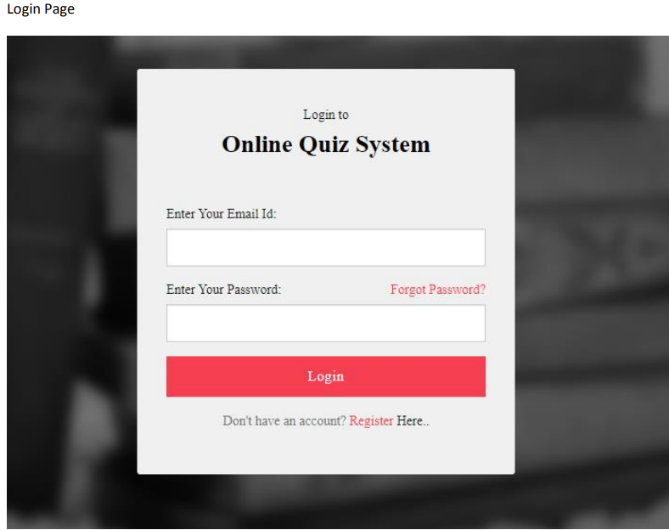

Admin Dashboard

m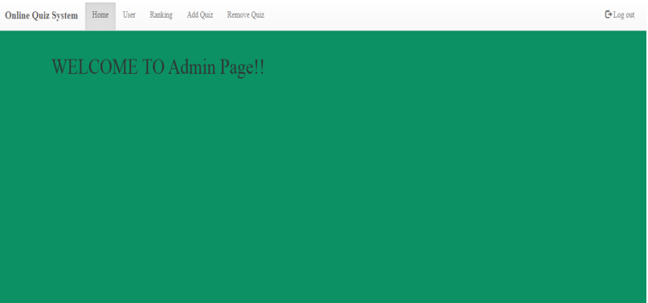

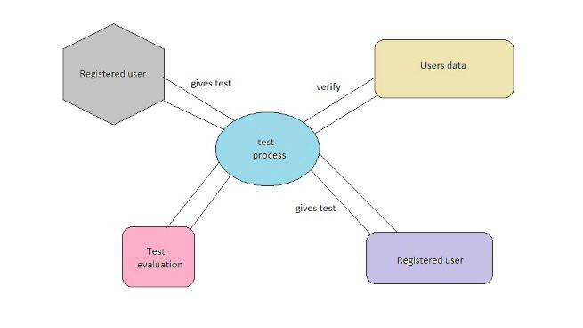

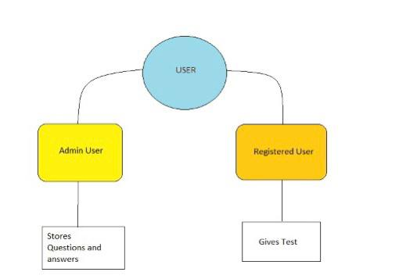

# Conclusion

As a conclusion, Online Quiz System has three main users who are admin, lecturer and student. For the admin, he can manage student and lecturer. For the student, student must login in the system, answer quiz and get the result of their quiz. For lecturer, lecturer can add question, schedule quiz and manage their class for their subject. This kind of system can be replaced the manual system in order to increase the efficiency of the quiz management. Next, the improvement should be done to make sure this system fulfill user requirements. In the future, there are still a lot features can be added into this system. Firstly, the pagination function should be built for a better and friendly view of users towards this system. Next, every process of entering data into system needs to have an efficient and accurate verification process.

## Reference links

1. <https://myfik.unisza.edu.my/www/fyp/fyp18semkhas/report/039981.pdf>
2. <https://en.wikipedia.org/wiki/Online_quiz>
3. Previous year projects .